DATABASE SYSTEMS – CSCE413

Final - Project

Team: -
Shreyas Kalammanagudi Shankaresh

(5 points) Goals. Describe the final project’s goals. In particular, you need to
describe who are the expected users and what service you provide for them. For
example, in a travel database system the customers are the potential travelers
and the service provided is to find travel paths and reservations for flights

Answer: -
This project aims to develop an innovative and robust database model that utilizes SQL queries—ranging from basic to complex nested queries—to extract application-specific subnetworks from a larger gene regulatory neural network (GRNN).
We have also tried to define and make some of the important constituents of the project understandable, such as ‘Network Plasticity - Alterations in the influence of one gene on another over time’. And ‘Network stability - Consistency of gene-to-gene interaction weights over time’, more similar concepts in the upcoming sections.
The primary goal is to create a system capable of isolating gene-gene interaction subnetworks that meet predefined criteria related to neural network properties such as stability, plasticity, and other essential metrics. By optimizing SQL query capabilities, this model maximizes the efficiency, precision, and scalability of retrieving subnetworks that align with specific functional needs.

2. (15 points) Database Design and Data. Draw an entity relationship diagram
for your database. Translate your entity relationship diagram into a database
scheme with at least five tables. Your design and database need to group
similar items together. For example, a House relation should contain several
houses instead of representing each house as a separate table. For each table
find suitable (raw) data from the internet or any publication in the library or
by creating your own data. Your data need to include one of the following:

a) Some spatial objects represented in the vector data model extended with
time instances when those objects existed. (If you have a jpeg image of a
spatial object, then you can define a polygon to approximate its shape.)
(b) A time series data of the form (x 1 , y 1 ), . . . , (x n , y n ).
(c) Some measurement data over a set of points on a map.
(d) Some moving objects data.
(e) Some data with classification information

E-R Diagram: -

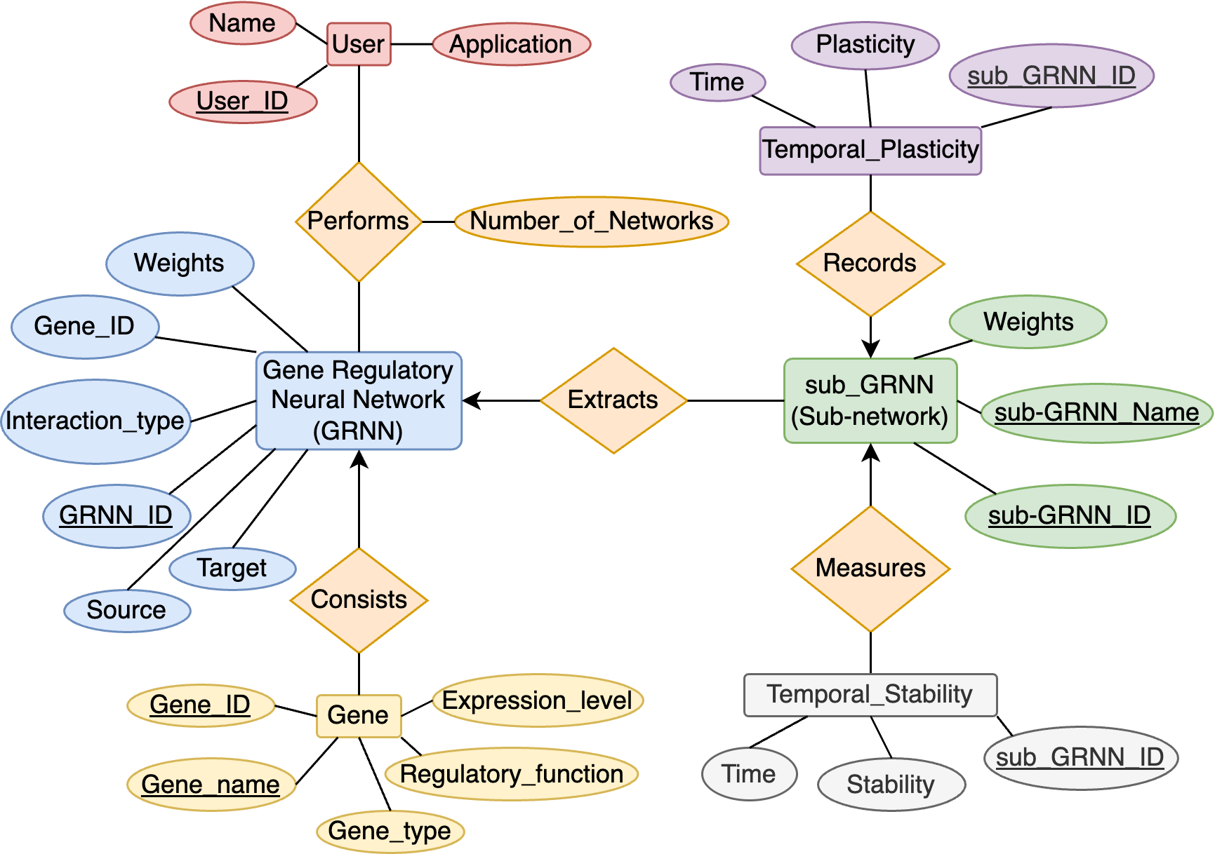

Design Overview: -

- Gene Regulatory Neural Network( GRNN_ID, Source, Target, Interaction Type, Gene ID, Weights)
- Gene(Gene ID, Gene Name, Gene_Type, Regulatory Function, Expression level)
- Sub-Gene Regulatory Neural Network(Sub-GRNN_ID, Sub-GRNN Name, Weights)
- Temporal_Stability(Sub-GRNN_ID, Time, Stability)
- Temporal_Plasticity(Sub-GRNN_ID, Time, Plasticity)
- User(User_ID, Name, Application)
- Performs(User_ID, GRNN_ID, Number of Networks)

Define Functions. At least two of the functions should be of the following type:

(a) Given the id of a spatial object S, find which other spatial objects intersect
with S’s area at any given time.
(b) Given a time instance, find an estimate of the value for a function at that
time.
(c) Given a point location, find an estimate of the measurement value at that
location.
(d) Given a time instance and the id of a moving object, find the location of
the moving object at that time.

(e) Given the data with classification information, build a SVM or decision
tree classifier.
Answer: -

1) Query to Extract Two-Layer Sub-networks :- It is the Query for extracting two-layer sub-GRNN (Sub- Network), compensating both the leaf/ input node and output node.
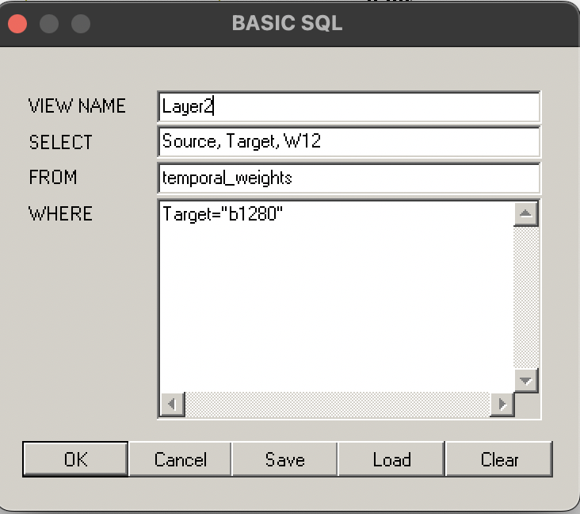

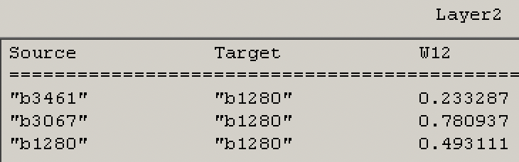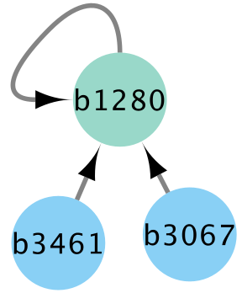
Input Node
Output node

2) Query to Extract Complex Structured Sub-networks: - It is the Query for extracting Three-layer sub-GRNN (Sub- Network).

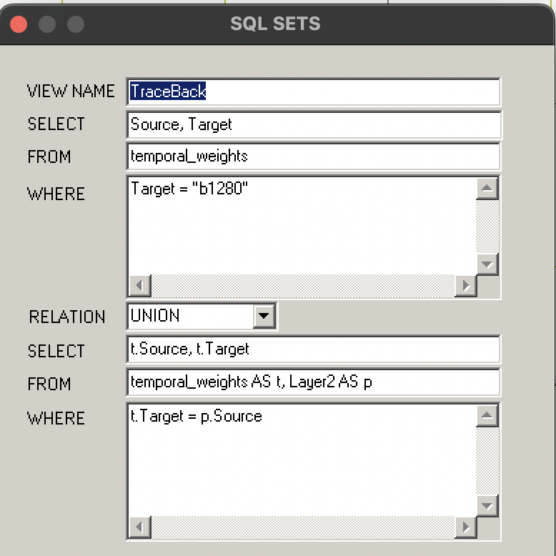

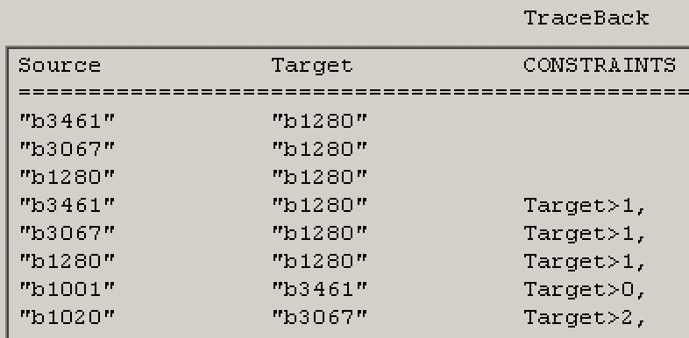
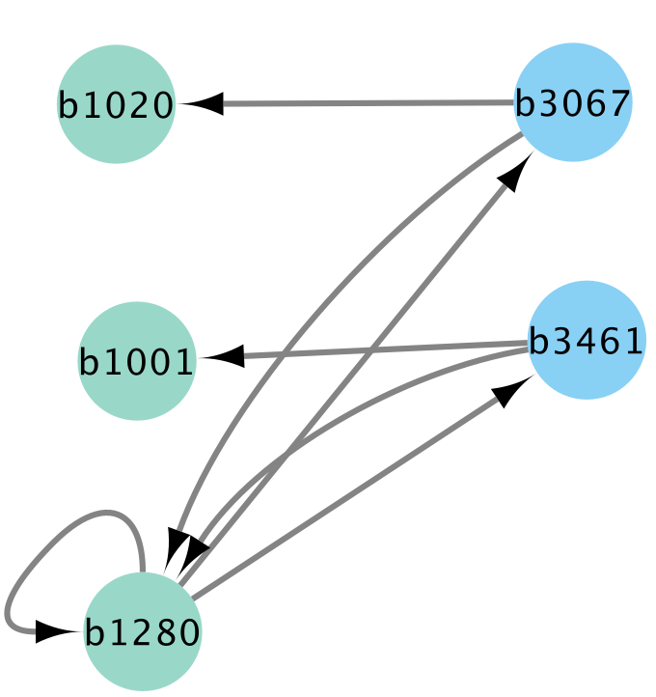
Representing Three level network

3) Query to Find the Temporal Weight Trajectory: - It is the query used to determine the temporal gene-gene interaction weights for given node
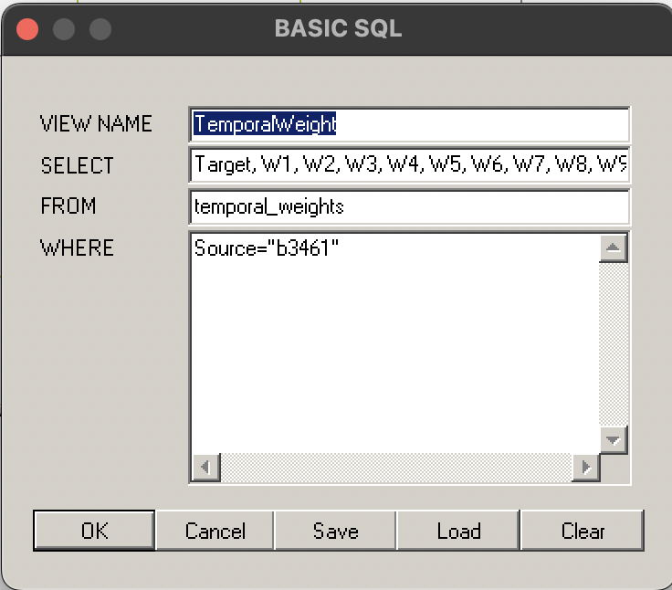

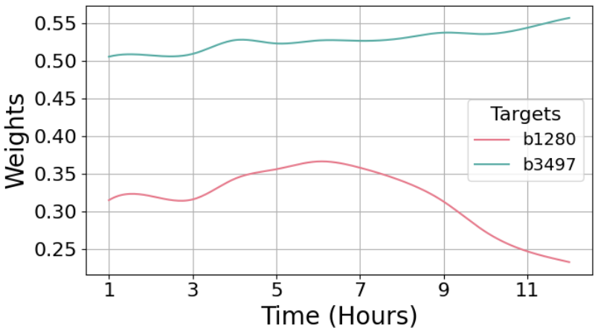
Temporal weights for the b3461 sub-GRNN

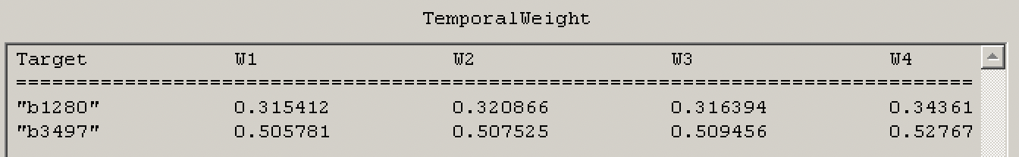

4) Query-driven Stability Estimation at a Specific Time: - This is the query to Estimate the stability at t=60 for the NetworkID=1 at particular instance of time.

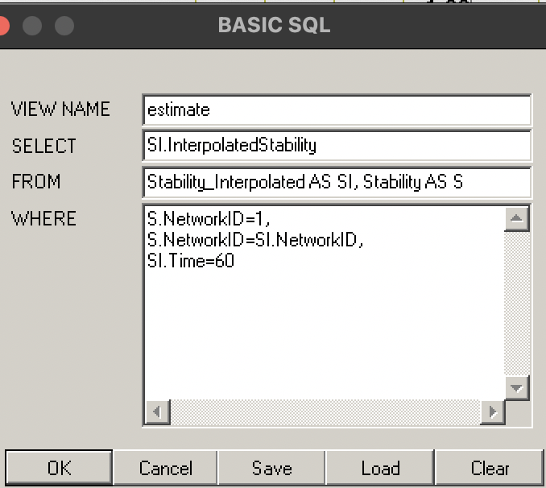
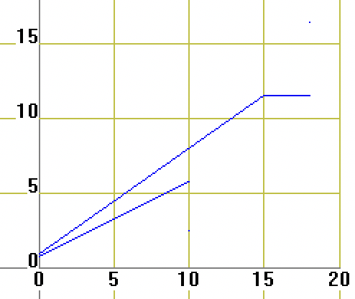
S
T
A
B
I
L
I
T
Y
Time

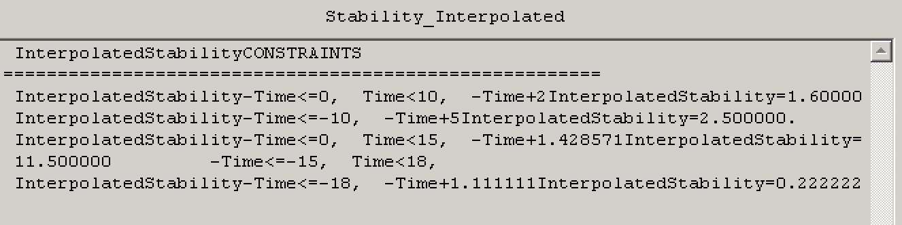

Fig. 12: Constraint relation for the stability estimation.

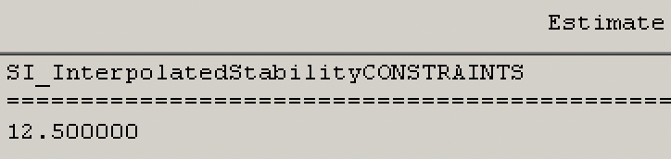
Fig. 13: Stability estimation at time $t=60$.

5) Plasticity Estimation via Bivariate Constraints: - This query finds and determines Plasticty estimation at time $t=60$ and $stability =0.5$.

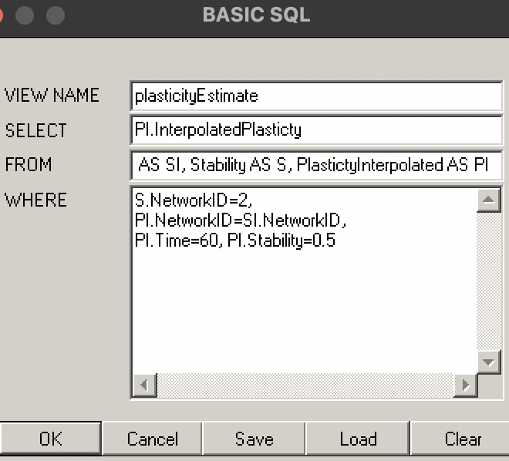

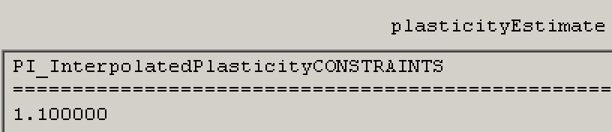
Fig. 15: Output.

5) Network Status Classification via Decision Tree: - This is the Decision tree model , that we have done using MLPQ system , which successfully determines the two important aspects of the project by considering the set of conditions and combinations.

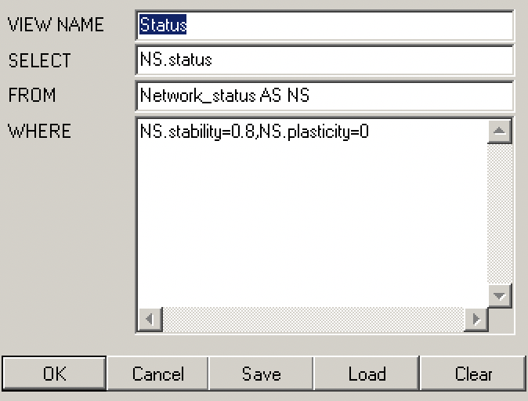
Query to find network status for stability 0.8 and plasticity 0.0.

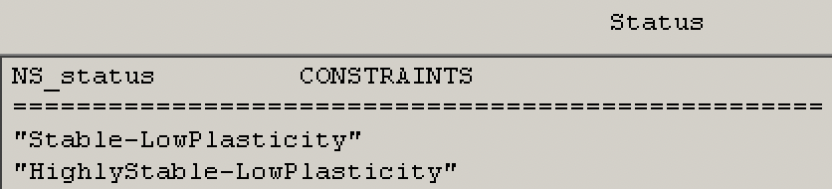
Network status classification.

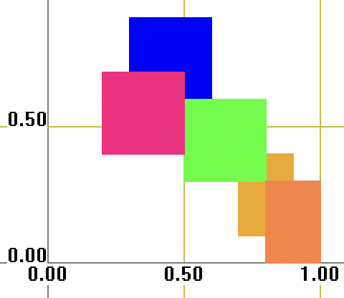
Stability
Plasticity

Stable-LowPlasticity
Unstable-HighPlasticity
Stable-MidPlasticity
Unstable-MidPlasticity
HighlyStable-LowPlasticity

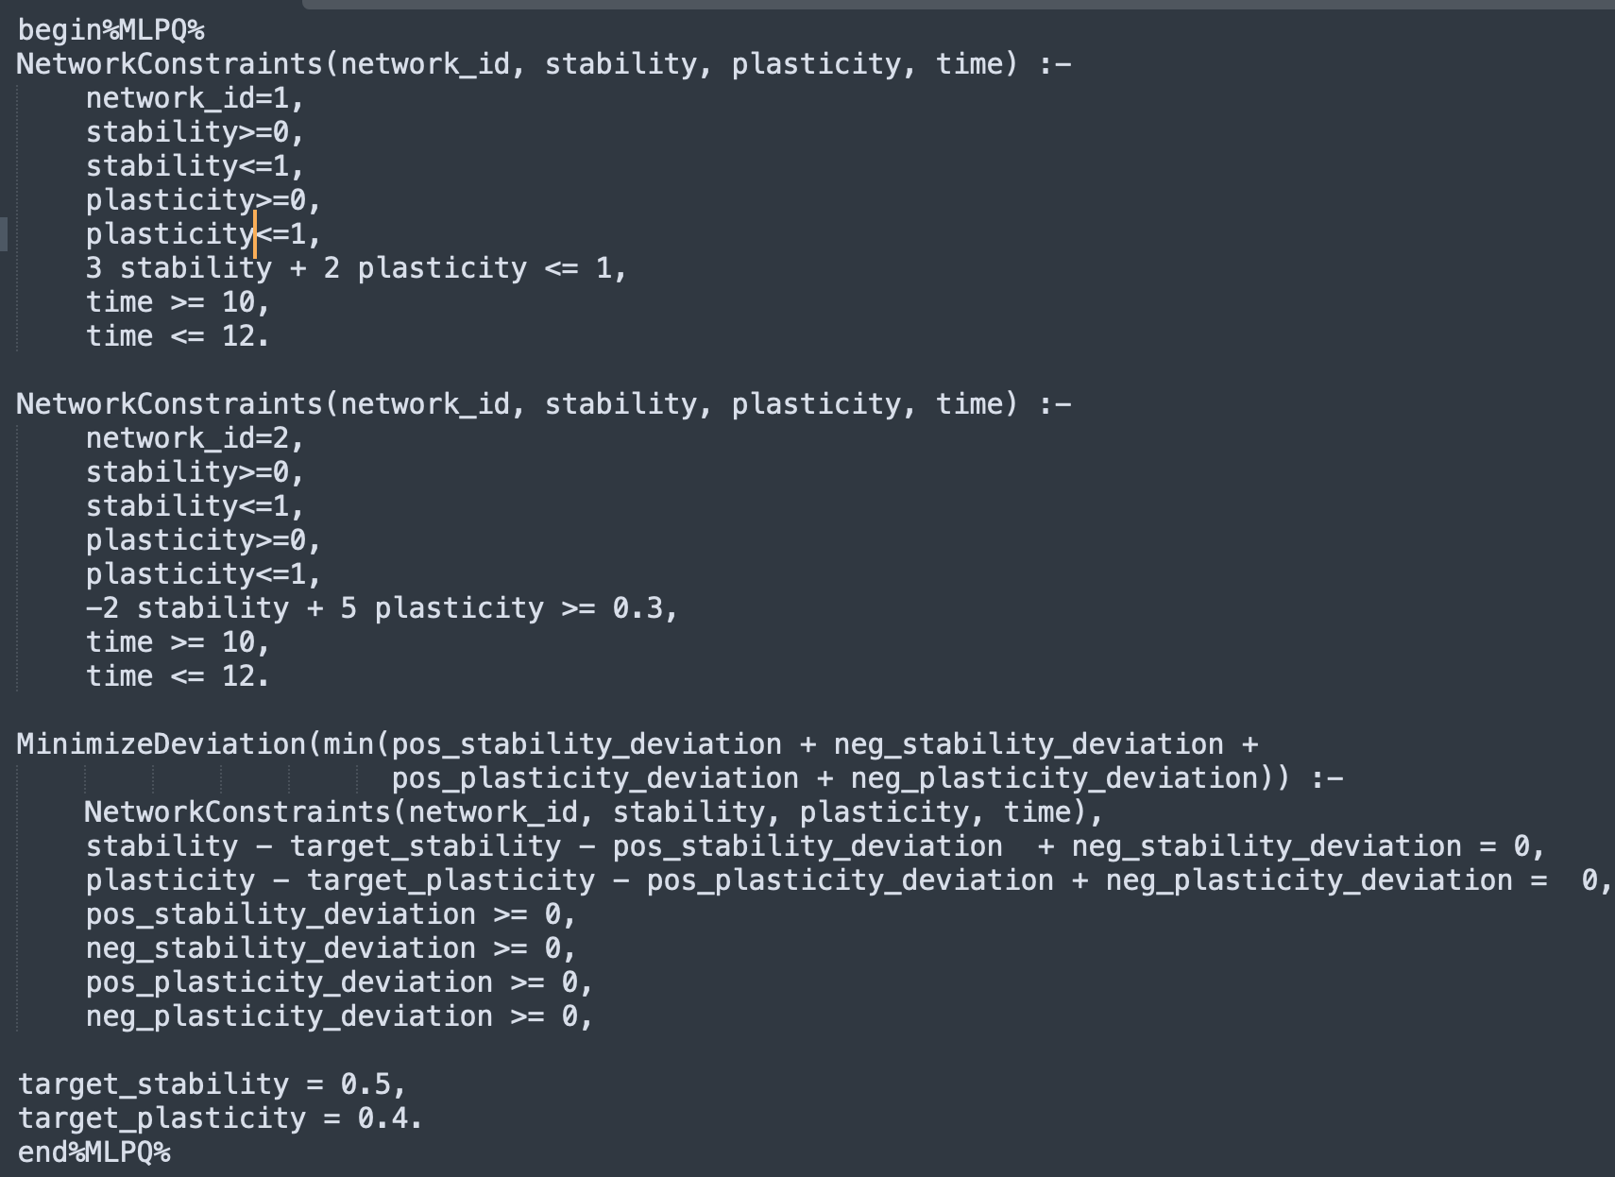
6) Linear Programming: -
Fig. 18: Constraint relation to minimize the stability plasticity trade-off.

Constraint relation to minimize the stability plasticity trade-off.

Result of Linear programming: -

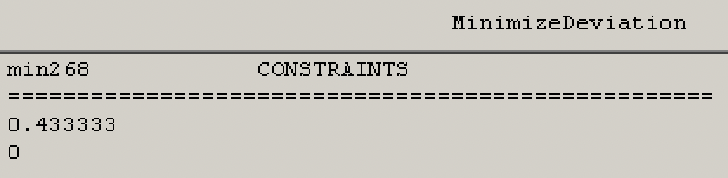
Fig. 19: The cost function values.

5)Class Presentation.
Answer:
PPT is attached in the zipped folder.

6)You can get up to five points bonus by doing one or two of the five choices below. Bonus points have to be limited to a maximum of ten points.
(a) Visualization of a geographic or spatial object, such as a map.
(b) Animation which shows spatio-temporal or moving objects.

Answer: -
A) To be attached from the MLPQ SYSTEM
B) Animated video has been attached in the power point presentation and it has been included in the zip folder.

